OSY PTT – 2 Question Bank
2 marks
1) Definition of Deadlock with diagram (Define =1M And Diagram=1 M)
Ans. A deadlock occurs when a set of processes is stalled (Halted) because each process is holding a resource and waiting for another process to acquire another resource.

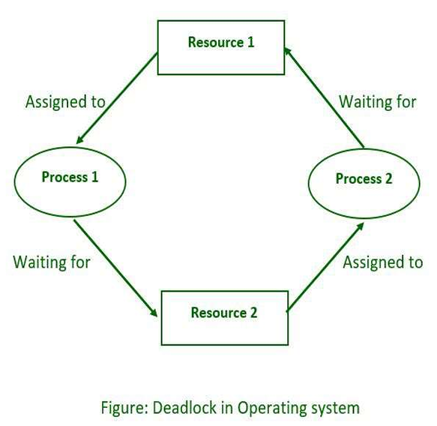

2) Define any four file operations. (Each = 0.5M)
Ans.
- Creating a File – Creating a new file.
- Opening a File – Opening a file for reading or writing.
- Reading a File – Getting data from a file.
- Writing a File – Adding or changing data in a file.
- Repositioning a File – Moving the file pointer to a particular location.
- Deleting a File – Removing a file from the storage.
- Truncating a File – Removing the contents of a file while keeping the file.
- Closing a File – Closing the file after the required operation is completed.

3) Define Swapping with diagram. (Define = 1M And Diagram = 1 M)
Ans. Swapping is a memory management technique in which a process is temporarily moved from main memory (RAM) to secondary storage (disk) and vice versa.
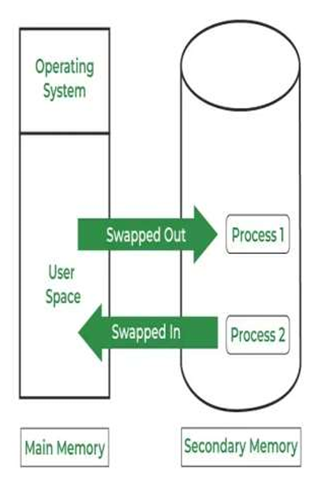
Fig : Swapping
4) Define fragmentation with its types. ( Define = 1M, Types = 0.5M)
Ans. Fragmentation is a memory management problem in which memory is wasted or remains unused during the allocation and deallocation of memory to processes.
Types of Fragmentation :-
1. Internal Fragmentation
2. External Fragmentation

5) Define any four file attributes (0.5 M each)
Ans.
- Name: The symbolic file name is the only information kept in human readable form.
- Type: This information is needed for those systems that support different types.
- Location: This information is a pointer to a device and to the location of the file on that device.
- Identifier: File system gives a unique tag or number that identifies file within file system and which is used to refer files internally.
- Size: The current size of the file (in bytes, words or blocks) and possibly the maximum allowed size are included in this attribute.
- Protection: Access control information determines that who can do reading, writing, executing and so on.
- Time, Date and User Identification: This information may be kept for creation, Last modification and last use. These data can be useful for protection, security and usage monitoring.

6) Define virtual memory. (1M for 1 point)
Ans.
- Virtual memory is a memory management capability of an operating system (OS) that uses hardware and software to allow a computer to compensate for physical memory shortages by temporarily transferring data from random access memory (RAM) to disk storage.
- Virtual memory is the separation of user logical memory from physical memory. This separation allows an extremely large virtual memory to be provided for programmers when only a smaller physical memory is available.
It is the process of increasing the apparent size of a computer's RAM by using a section of the hard disk storage as an extension of RAM.

7) Define (1M each)
(i) Turnaround time ( ii) Throughput

Ans. i. Turnaround Time :-
The time interval from the time of submission of a process to the time of completion of that process is called as turnaround time. It is the sum of time period spent waiting to get into the memory, waiting in the ready queue, executing with the CPU, and doing I/O operations.
ii. Throughput :-
It is the number of processes that are completed per unit time. It is a measure of work done in the system. Throughput depends on the execution time required for any process. For long processes, throughput can be one process per unit time whereas for short processes it may be 10 processes per unit time.

8) Differentiate between Paging and Segmentation (any 4)
Ans.
Sr. No. | Paging | Segmentation
1. | It divides the physical memory into frames and program’s address space into same size pages. | It divides the Computer’s physical memory and program’s address space into segments.
2. | Page is always of fixed block size. | Segment is of variable size.
3. | The size of page is specified by the hardware. | The size of the segment is specified by the user.
4. | Invisible to Programmer. | Visible to Programmer.

9) Differentiate between Fixed Size Partition and Variable Size Partition (any 4)
Ans.
Sr. No. | Fixed – Size Partition | Variable – Size Partition
1. | OS decides the size of the partition only once during the system boot time, It can’t be changed. | OS decides the size of the partition according to the size of the process. The size of the partition can be changed.
2. | Fix the degree of multiprogramming. | The degree of multiprogramming will vary according to the size of the processes.
3. | It supports internal fragmentation. | It supports external fragmentation.
4. | Static partitioning. | Dynamic partitioning.

10) Define term page fault. (1M for 1 point)
Ans.
- A page fault is trap that occurs when the requested page is not loaded into the memory.
- In other words, when a program tries to access a chunk of memory that does not exist in physical memory (main memory) causes a page fault.

11) Describe First Fit, Best Fit, Worst Fit along with example. (Describe = 1M, Example = 1M)
Ans. First Fit : In this type fit, the partition is allocated, which is the first sufficient block from the beginning of the main memory.
Best Fit : It allocates the process to the partition that is the first smallest partition among the free partitions.
Worst Fit : It allocates the process to the partition, which is the largest sufficient freely available partition in the main memory.

Example : -
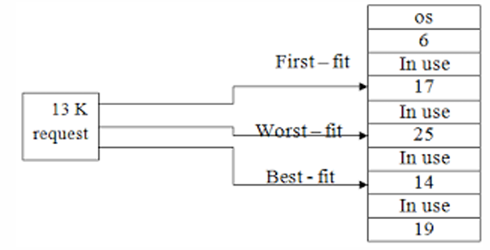

4 marks
12) Explain partitioning and its types. (Explanation = 1M,
each types Explanation = 1.5 M)
Ans.
1. It divides primary memory into various memory partitions, which is mostly contiguous areas of memory.
2. Every partition stores all the information for a specific task or job.
3. This method consists of allotting a partition to a job when it starts & unallocated when it ends.
Two Methods :
1. Static (Fixed Sized) Memory Partitioning 2. Dynamic (Variable Sized) Memory Partitioning

1. Static (Fixed sized) Memory Partitioning :
In this partitioning, the number of partitions (non-overlapping) in RAM is fixed but the size of each partition may or may not be the same.
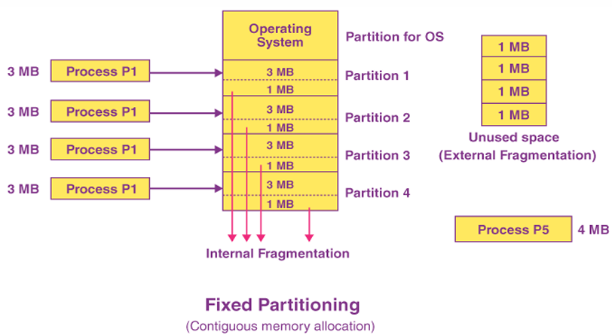
2. Dynamic (Variable sized) Memory Partitioning :
In dynamic partitioning, the partition size initially isn’t declared. It’s declared at the moment of process loading.
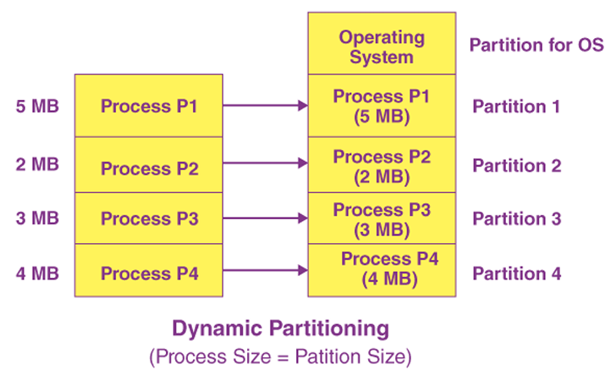

13) Describe sequential and direct access method with diagram. (Each option = 2M)
Ans.
1. Sequential Access Method
Sequential access is a file access method in which data is accessed in a specific order, one record after another, from the beginning to the end of the file.
- In sequential access, the OS read the file word by word.
- Records are accessed sequentially.
- To access a particular record, the preceding records may need to be read.
- It is commonly used in magnetic tapes and log files.
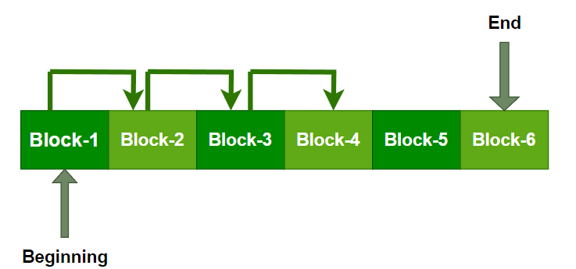
Fig : Sequential Access Method

2. Direct Access Method
Direct access is a file access method in which data can be accessed directly from any location without reading the preceding records.
- Another method is direct access method also known as relative access method.
- A filed-length logical record that allows the program to read and write record rapidly. in no particular order.
- The direct access is based on the disk model of a file since disk allows random access to any file block.
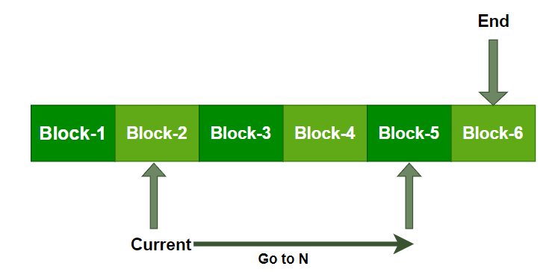
Fig : Direct Access Method

14) State any three file types along with their usual extensions. What is the need of file extension ?
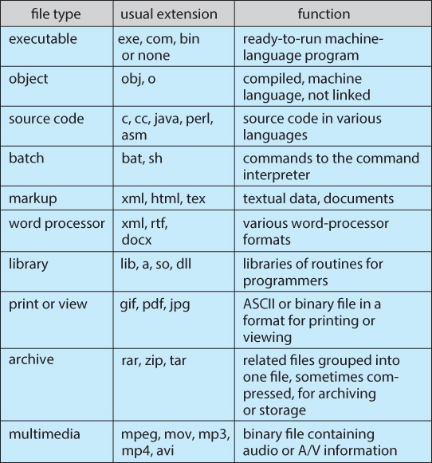
Need of File Extension :-
- File Identification : Helps identify the type and format of a file.
- Application Selection : Helps the operating system select the appropriate application to open a file.
- File Organization : Helps users organize and categorize files easily.
- File Management : Makes it easier to search, sort and manage different files.

15) Necessary Conditions for Deadlock With diagram. (Each option = 1M)
Ans. There are four different conditions that result in Deadlock.
These four conditions are also known as Coffman conditions as follows :-
1. Mutual Exclusion 2. Hold and Wait
3. No Preemption 4. Circular Wait

1. Mutual Exclusion : A resource can only be held and used by one process at a time. While other processes can request the resource, they cannot use it simultaneously with the current holder.
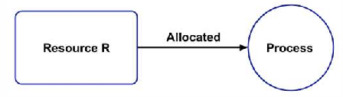
Fig : Mutual Exclusion

2. Hold and Wait : Processes can hold multiple resources simultaneously while also requesting additional resources currently held by other processes (e.g., process $P1$ holding $R1$ and $R2$ while requesting $R3$ from process $P2$).

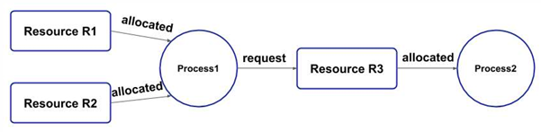
Fig : Hold and Wait

3. No Preemption : A resource cannot be forcefully taken away from a process while it is in use. A process must release the resource voluntarily; other processes can only request it and wait until it becomes free.

4. Circular Wait : Circular wait occurs when a chain of processes forms where each process holds a resource needed by the next in line, and the final process waits for a resource held by the first. Because everyone is waiting and no one is releasing their resources, the system hits a deadlock.
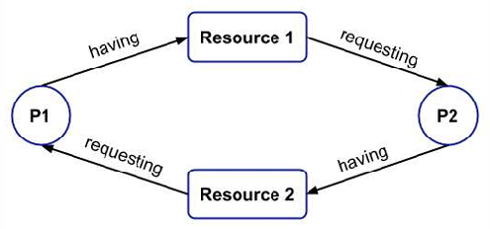
Fig : Circular Wait

16) Explain following terms with respect to Memory management :
i. Compaction ii. Segmentation.
{Each option = 2M(Explanation 1M Diagram 1M)}

Ans.
i. Compaction
- Compaction is a technique to collect all the free memory present in form of fragments into one large chunk of free memory, which can be used to run other processes.
- It does that by moving all the processes towards one end of the memory and all the available free space towards the other end of the memory so that it becomes contiguous.
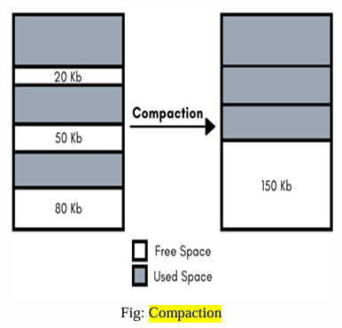

ii. Segmentation
- Segmentation divides the user program and the secondary memory into uneven-sized blocks known as Segments.
- Segmentation divides processes into smaller subparts known as modules. The divided segments need not be placed in contiguous manner.

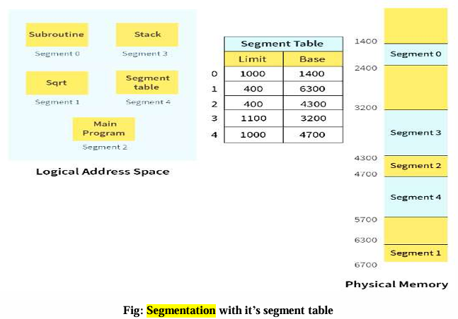

17) Describe Bitmap-free space management technique with example. (Explanation =3M And Diagram=1 M)
Ans.
- A bit vector is the most frequently used method to implement the free space list.
- A bit vector is also known as a "Bit map".
- It is a series or collection of bits in which each bit represents a disk block.
- The values taken by the bits are either 1 or 0.
- If the block bit is 1, it means the block is free and if the block bit is 0, it means the block is not free (occupied).
For example, consider a disk where blocks 2, 3, 4, 5, 8, 9, 10, 11, 12, 13 are free and the rest of the blocks are allocated.
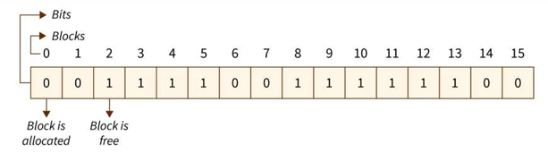

The free-space bit map would be : 0011110011111100

6 marks
18) Explain LRU page replacement algorithm for following reference string. 7 0 1 2 0 3 0 4 2 3 0 3 2 1 2 0 1 7 0 1 Calculate the page fault and page hit.
(LRU explanation =2M Calculation =4 M)
Ans. Least Recently Used ( LRU ):
- The Least Recently Used (LRU) page replacement policy replaces the page that has not been used for the longest period of time.
- LRU replacement associates with each page the time of that page's last use.
- When a page must be replaced, LRU chooses the page that has not been used for the longest period of time.
- The LRU policy is often used as a page-replacement algorithm and is considered to be good.
- An LRU page-replacement algorithm may require substantial hardware assistance.
Counters:
- In the simplest case, we associate with each page-table entry a time-of-use field and add to the CPU a logical clock or counter.
- The clock is incremented for every memory reference.
- Whenever a reference to a page is made, the contents of the clock register are copied to the time-of-use field in the page table entry for that page.
- In this way, we always have the "time" of the last reference to each page. We replace the page with the smallest time value.
Stack:
- Another approach to implementing LRU replacement is to keep a stack of page numbers.
- Whenever a page is referenced, it is removed from the stack and put on the top.
- In this way, the most recently used page is always at the top of the stack and the least recently used page is always at the bottom.

Reference String: 7 0 1 2 0 3 0 4 2 3 0 3 2 1 2 0 1 7 0 1
(Frame size have not mentioned in question so assume frame size as 3 or 4)

LRU: Assume frame size=3

7 | 0 | 1 | 2 | 0 | 3 | 0 | 4 | 2 | 3 | 0 | 3 | 2 | 1 | 2 | 0 | 1 | 7 | 0 | 1

F1 | 7 | 7 | 7 | 2 |  | 2 |  | 4 | 4 | 4 | 0 |  |  | 1 |  | 1 | * | 1 |  | *
F2 |  | 0 | 0 | 0 | * | 0 | * | 0 | 0 | 3 | 3 | * |  | 3 |  | 0 |  | 0 | *
F3 |  |  | 1 | 1 |  | 3 |  | 3 | 2 | 2 | 2 |  | * | 2 | * | 2 |  | 7
S | F | F | F | F | H | F | H | F | F | F | F | H | H | F | H | F | H | F | H | H

* indicates page Hits
Total Page Faults : - 12
Total Page Hits : - 8
19) Enlist different file allocation methods ? Explain contiguous allocation method in detail with Advantages and Disadvantages ?
(1m- listing, 2m for diagram, 3m for explanation)
Ans.
Different file allocation methods are as follows :-
- Contiguous Allocation
- Linked Allocation
- Indexed Allocation

Contiguous Allocation
Contiguous allocation is a file allocation method in which each file occupies a set of consecutive (continuous) disk blocks. The starting block and length of the file are stored in the directory.

- The contiguous allocation method requires each file to occupy a set of contiguous addresses on the disk. Disk addresses define a linear ordering on the disk. Contiguous allocation of a file is defined by the disk address of the first block and its length. If the file is ‘n’ blocks long and starts at location ‘b’, then it occupies blocks b, b+1, b+2, - - - - - b+n-1. The directory entry for each file indicates the address of the starting block and the length of the area allocated for this file.
- Contiguous allocation supports both sequential and direct access
- The difficulty with contiguous allocation is finding space for a new file.
- If file to be created are ‘n’ blocks long, we must search free space list for ‘n’ free contiguous blocks.

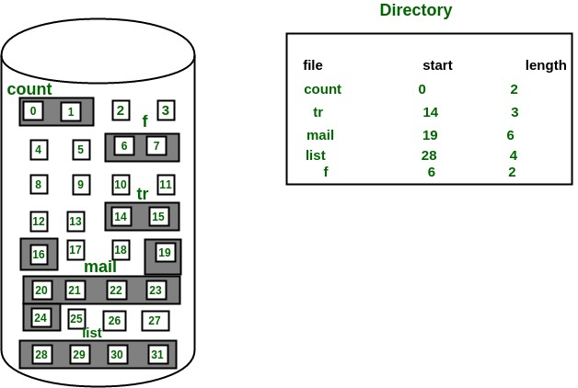
Fig : Contiguous Allocation
Advantages
- It is very easy to implement.
- There is a minimum amount of seek time.
- The disk head movement is minimum.
- Memory access is faster.
- It supports sequential as well as direct access.
Disadvantages
- At the time of creation, the file size must be initialized.
- As it is pre-initialized, the size cannot increase. As
- Due to its constrained allocation, it is possible that the disk would fragment internally or externally.

20) Explain working of Non-contiguous memory management technique-paging with diagram of paging hardware. (Explanation = 4M And Diagram = 2 M)
Ans.
Paging (Non-Contiguous Memory Management)
Paging is a non-contiguous memory management technique in which a process is divided into fixed-size blocks called pages, and physical memory is divided into fixed-size blocks called frames. Pages can be stored in any available frames in main memory.

Working of Paging
- Paging
- The process is divided into fixed-size pages, and main memory is divided into equal-sized frames.
- The pages of a process are loaded into any available frames in main memory.
- The page table maintains the mapping between page numbers and frame numbers.
- The CPU generates a logical address, which is divided into a page number and an offset.
- The page number is used to find the corresponding frame number in the page table.
- The frame number and offset are combined to generate the physical address.
- Address Translation:
The logical address (used by the process) consists of:
- Page number (identifies which page of the process).
- Page offset (identifies the specific byte within the page).
The physical address (used by the system) consists of:
- Frame number (points to the location in main memory).
- Page offset (remains the same as the logical address).
- Page Table:
- A page table is a data structure that keeps track of the mapping between the process's pages and the physical memory frames.
- It helps in translating logical addresses into physical addresses during execution.
- Frame Allocation: When a page is allocated a frame in memory, the logical address is translated into a physical address using the page table. This mapping is maintained throughout the program’s execution.
- Memory Management During Execution:
- If a program (e.g., 8KB in size) cannot fit completely into memory (say, only 5KB can be loaded at once), the system uses paging to manage this.
- The OS moves idle pages to secondary memory (like disk storage) when RAM is full, freeing up space for active pages.
- When the program needs those pages again, the OS retrieves them from secondary memory and loads them back into RAM.
- Continuous Paging: This process of swapping pages between RAM and secondary memory continues throughout the execution of the program to ensure the system runs efficiently despite limited RAM.4

Diagram of Paging Hardware
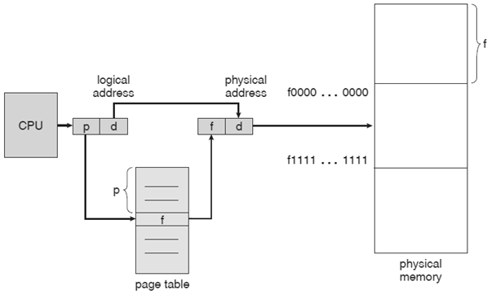
Fig: Paging Hardware

21) Consider the reference string: 2, 3, 4, 5, 3, 2, 6, 7, 3, 2, 3, 4, 1, 7, 1, 4, 3, 2, 3, 4, 7 with frame size 3. Calculate page fault and page hit using FIFO, LRU and optimal page replacement algorithm. (Each Calculation = 2 M)

Ans.
Reference String: 2, 3, 4, 5, 3, 2, 6, 7, 3, 2, 3, 4, 1, 7, 1, 4, 3, 2, 3, 4, 7
Frame Size: 3

1. FIFO (First In First Out)
Page | 2 | 3 | 4 | 5 | 3 | 2 | 6 | 7 | 3 | 2 | 3 | 4 | 1 | 7 | 1 | 4 | 3 | 2 | 3 | 4 | 7
F1 | 2 | 2 | 2 | 5 | 5 | 5 | 5 | 7 | 7 | 7 | 7 | 4 | 4 | 4 | 4 | 4 | 3 | 3 | 3 | 3 | 7
F2 | – | 3 | 3 | 3 | 3 | 2 | 2 | 2 | 3 | 3 | 3 | 3 | 1 | 1 | 1 | 1 | 1 | 2 | 2 | 2 | 2
F3 | – | – | 4 | 4 | 4 | 4 | 6 | 6 | 6 | 2 | 2 | 2 | 2 | 7 | 7 | 7 | 7 | 7 | 7 | 4 | 4
Status | F | F | F | F | H | F | F | F | F | F | H | F | F | F | H | H | F | F | H | F | F

Page Fault = 16 Page Hit = 5
2. LRU (Least Recently Used)
Page | 2 | 3 | 4 | 5 | 3 | 2 | 6 | 7 | 3 | 2 | 3 | 4 | 1 | 7 | 1 | 4 | 3 | 2 | 3 | 4 | 7
F1 | 2 | 2 | 2 | 5 | 5 | 5 | 6 | 6 | 6 | 2 | 2 | 4 | 4 | 4 | 4 | 4 | 4 | 4 | 4 | 4 | 7
F2 | – | 3 | 3 | 3 | 3 | 3 | 3 | 7 | 7 | 7 | 7 | 7 | 1 | 1 | 1 | 1 | 1 | 2 | 2 | 2 | 2
F3 | – | – | 4 | 4 | 4 | 2 | 2 | 2 | 3 | 3 | 3 | 3 | 3 | 7 | 7 | 7 | 3 | 3 | 3 | 3 | 3
Status | F | F | F | F | H | F | F | F | F | F | H | F | F | F | H | H | F | F | H | H | F

Page Fault = 15 Page Hit = 6

3. Optimal Page Replacement
Page | 2 | 3 | 4 | 5 | 3 | 2 | 6 | 7 | 3 | 2 | 3 | 4 | 1 | 7 | 1 | 4 | 3 | 2 | 3 | 4 | 7
F1 | 2 | 2 | 2 | 2 | 2 | 2 | 2 | 2 | 2 | 2 | 2 | 4 | 4 | 4 | 4 | 4 | 4 | 4 | 4 | 4 | 4
F2 | – | 3 | 3 | 3 | 3 | 3 | 3 | 3 | 3 | 3 | 3 | 3 | 3 | 3 | 1 | 1 | 3 | 3 | 3 | 3 | 3
F3 | – | – | 4 | 5 | 5 | 5 | 6 | 7 | 7 | 7 | 7 | 7 | 1 | 7 | 7 | 7 | 7 | 2 | 2 | 2 | 7
Status | F | F | F | F | H | H | F | F | H | H | H | F | F | H | H | H | F | F | H | H | F

Page Fault = 11 Page Hit = 10

22) Explain and List free space management techniques? Describe Linked list in detail. (Listing = 1M Explanation = 3M And Diagram = 2 M)
Ans.
- There is a system software in an operating system that manipulates and keeps track of free spaces to allocate and de-allocate memory blocks to files, this system is called a "file management system in an operating system". There is a "free space list" in an operating system that maintains the record of free blocks.
- When a file is created, the operating system searches the free space list for the required space allocated to save a file. While deletion a file, the file system frees the given space and adds this to the "free space list".

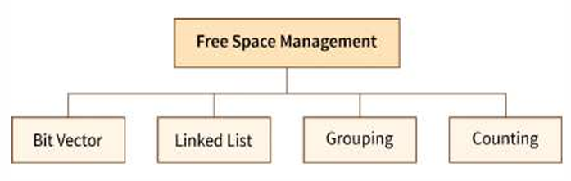

Linked List : -
1. A linked list is another approach for free space management in an operating system. 2. In it, all the free blocks inside a disk are linked together in a "linked list".
3. These free blocks on the disk are linked together by a pointer.
4. These pointers of the free block contain the address of the next free block and the last pointer of the list points to null which indicates the end of the linked list.
5. This technique is not enough to traverse / search the list because we have to read each disk block one by one which requires I/O time.

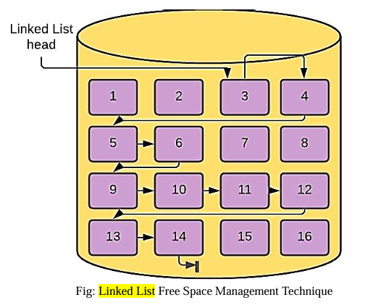

Advantage of the Linked list :
- In this method, available space is used efficiently.
- As there is no size limit on a linked list, a new free space can be added easily.
Disadvantages :
- In this method, the overhead of maintaining the pointer appears.
- The Linked list is not efficient when we need to reach every block of memory.

23) Construct and explain directory structure of a file system in terms of single level, two level and tree structure. {Each level = 2M(Explanation 1M Diagram 1M)}

Ans.
Directory Structure of a File System
A directory structure is a way of organizing files and folders in an operating system. It helps users store, manage, search and access files efficiently.
It can also be considered as a collection of the correlated files on the disk. It organizes the files and folders in a gradual and hierarchical manner.

There are three types of directory structures : -

1. Single-Level Directory
- It is the simplest directory structure. In a single-level directory, there is only one directory in the system, meaning there is only one folder, and all the files are stored in that single directory. There is no way to segregate important files from non-important files.
- All the folders/files are contained under the same directory which is called the root directory
- The single-level directory structure keeps all files in a single root, with no separate directory present for grouping, which makes it easy to support and understand.

Diagram : Single Level Directory Structure
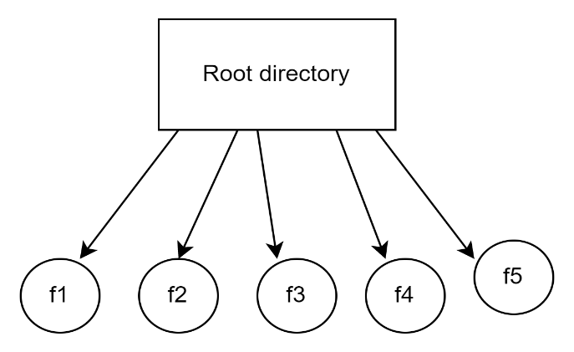

2. Two-Level Directory
- In a two-level directory structure, there is a master node that has a separate directory for each user.
- Each user can store the files in that directory.
- It can be practically thought of as a folder that contains many folders, each for a particular user, and now each user can store files in the allocated directory just like a single level directory.

Diagram : Two Level Directory Structure
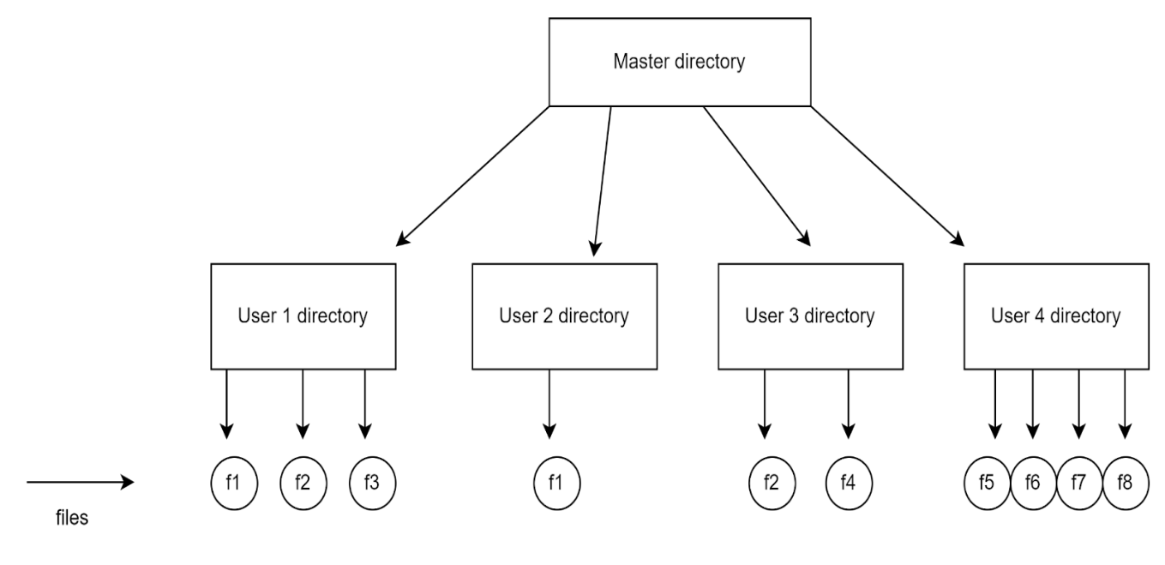

3. Tree-Structured Directory
- The directory is structured in the form of a tree. It also has a root directory, and every file in the system has a unique path.
- A directory within a tree-structured directory may contain files or subdirectories. Special system calls are used to create or remove directories.
- One bit in each directory entry is used to identify the entry as either a file (represented by ‘0’) or a directory (represented by ‘1’).
- The tree directory structure is the most common in personal computers.
- The Tree-Structured directory structure in OS is said to be the most common hierarchical structure used by modern operating systems, as it gives users the capability to create sub-directories under their defined directory.

Diagram : Tree Structured Directory Structure

